***Registration Form***

Parents as Partners in

Professional Development

(P3D) in Early Intervention

Name

Address:

Check location choice:

May 6, 2014 - PaTTAN Pittsburgh

May 13, 2014 – PaTTAN Harrisburg

Phone:

Email:

**B**

**Spring 2016 Family Training**

**Family Leaders: Promoting Inclusion in Early Childhood**

**Please register no later than Friday, April 29, 2016**

**To support my participation in this event, I will need:**

*(Please check all that apply)*

Special Meal (indicate vegetarian or gluten free)

Overnight Hotel Room (for travel over 50 miles)

*(We will contact you if lodging is requested. Lodging request must be made by Friday, April 22nd)*

Childcare Reimbursement

Travel Reimbursement

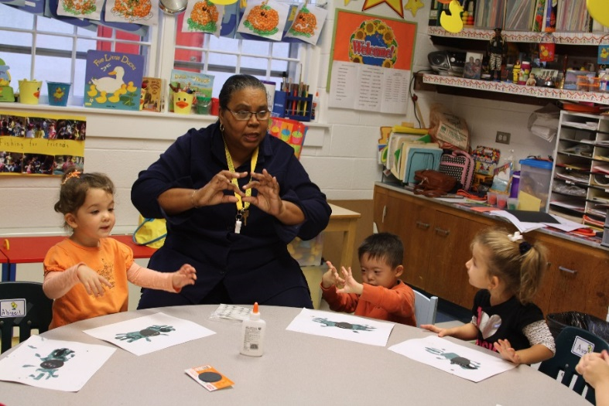

***Tuesday, May 10, at PaTTAN Harrisburg***

***9:30 AM to 3:30 PM***

***Registration - 9:00 AM***

**Please email, fax, or mail completed registration form to:**

**Suzanne Pasquariello** [**spasq@pattan.net**](mailto:spasq@pattan.net)

**Phone: 610-265-7321 x7229**

**Fax: 610-265-5737**

**Mail: PATTAN**

**200 Anderson Road**

**King of Prussia, PA 19406**

**Attn: Suzanne Pasquariello**

**cid:image001.png@01CE0439.CD4940A0**

**When and Where?**

**Tuesday, May 10, 2016**

**PaTTAN Harrisburg**

**6340 Flank Drive**

**Harrisburg, PA 17112**

**Time 9:30 AM to 3:30 PM**

**Registration – 9:00 AM**

* lunch provided
* no fee for this training
* reimbursement for childcare and travel expenses
* hotel accommodations available with pre-arrangement

If you have special needs as addressed by the Americans with Disabilities Act and need assistance at this training, please contact Suzanne Pasquariello, PaTTAN King of Prussia at 610-265-7321 x7229 or [spasq@pattan.net](mailto:spasq@pattan.net) Reasonable efforts will be made to accommodate you.

**Registration form on the back**

**What’s New at OCDEL?**

Now is an exciting time for PA families as the Office of Child Development and Early Learning (OCDEL) is embarking on integrating early childhood systems and developing new priorities. Families have a critical, much-needed role in providing input into this process and partnering as we move forward to achieve our goals. Join us for a day long opportunity to learn about these changes, participate in facilitated discussion and commit to being part of this transformation.

***This workshop is designed for family members of children eight years old and under who have participated in early intervention services.***

Please join us for this wonderful day of networking and learning.

Learning Objectives

1. Learn about OCDEL-wide collaborative endeavors to support inclusion
2. Brainstorm on supports YOU and YOUR CHILD need to be included
3. Connect with upcoming Early Intervention Professional Development and Family Training
4. Identify opportunities to promote inclusion using your P3D skills
5. Network with other families

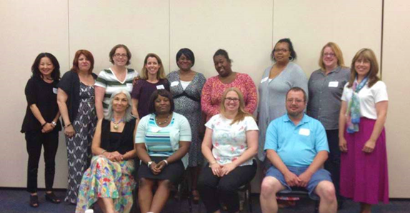

**C2P2 EI Graduates at Spring 2015 Family Training**

**P3D**