**Families Coming Together:**

**The Value and Role of Family Perspective**

**Registration Form**

Name ______________________________________

Address ____________________________________

___________________________________________

Phone _____________________________________

Email ______________________________________

**Please register by Friday, May 10, 2019**

Encourage a friend to register!

**cid:image001.png@01CE0439.CD4940A0**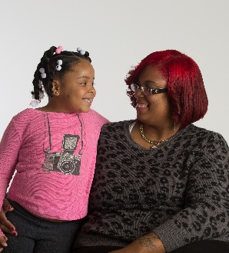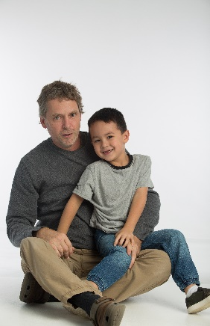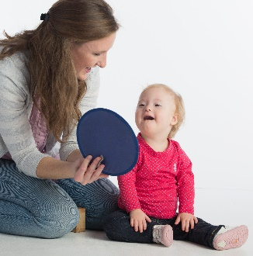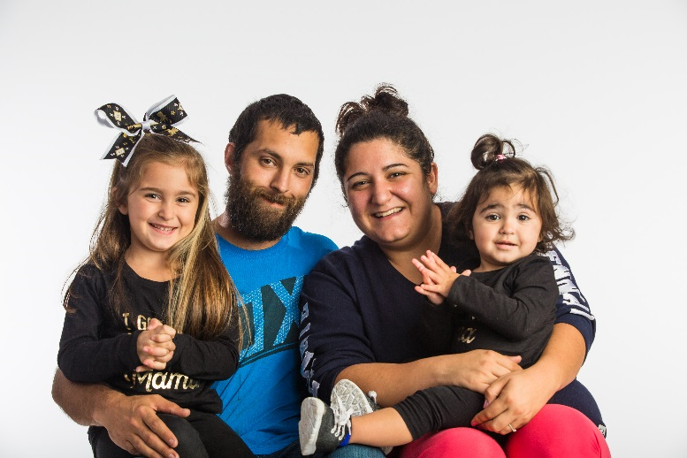

Expanding the Power of Family Knowledge, Insight and Perspective

Please email, fax, or mail completed registration form to:

Suzanne Pasquariello at [spasq@pattan.net](mailto:spasq@pattan.net)

Fax: 610-265-5737

Mail: PATTAN

333 Technology Drive

Malvern, PA 19355

Attn: Suzanne Pasquariello

Parents as Partners in Professional Development (P3D)

To support my participation in this event, I will need:

(Please check all that apply)

___ Special Meal (indicate vegetarian or gluten free)

___ Overnight Hotel Room (for travel over 50 miles)

We will contact you if lodging is requested. (**Lodging requests must be made by Tuesday, April 30, 2019**)

___ Childcare Reimbursement

___ Travel Reimbursement

**Thursday, May 16, 2019**

**PaTTAN Harrisburg**

**9:30 AM to 3:30 PM**

As one voice, we promote

communities where all children can

play, learn, and grow together!

This event is open to families of children in Early Intervention

Invite a friend to register and attend!

What you can expect during this event:

1. Discover how all family stories and perspectives can have an impact.
2. Learn how to craft your family story to have a positive impact.
3. Network with other families.
4. Provide input to the OCDEL Family Survey.
5. Receive information about OCDEL resources and upcoming events.

**TOGETHER WE ARE BETTER!**

Families have an important story to share and expertise to contribute. Through sharing our perspective and knowledge, we strengthen Early Intervention Services, programs, and policy.

This year’s P3D event offers opportunities to both build your family story and to provide input into the revision of the Early Intervention Family Survey. We will provide a framework to help craft and share your unique journey as a family. We will also discuss how the Family Survey fits into our federal reporting requirements and request your input into its content and dissemination. Information on family engagement and leadership opportunities will be discussed.

Now is an exciting time for families. Please join us!

**When and Where?**

**Thursday, May 16, 2019**

**PaTTAN Harrisburg**

**6340 Flank Drive**

**Harrisburg, PA 17112**

**Time 9:30 AM to 3:30 PM**

**Check-in opens at 9:00 AM**

* No fee for this event
* Lunch is provided
* Reimbursement for childcare & travel expenses
* Hotel accommodations available with pre-arrangement

If you have special needs as addressed by the Americans with Disabilities Act and need assistance at this training, please contact Suzanne Pasquariello at 610-265-7321 x7229 or [spasq@pattan.net](mailto:spasq@pattan.net). Reasonable efforts will be made to accommodate you.

**Please register using the form on the back.**