Data Collection and Planning – Notetaking Tool

County or Program: Team Members:
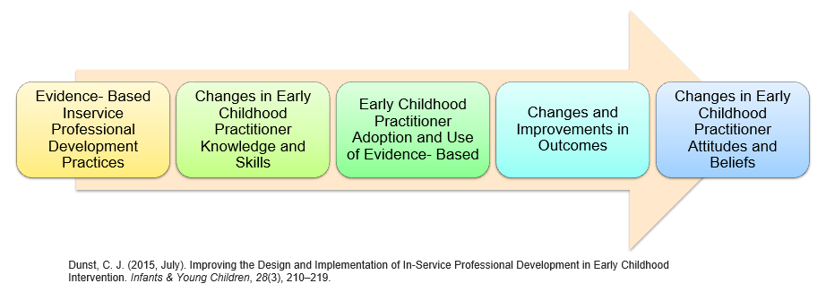

What do you want to know related to these areas? What critical question(s) do you want to answer?

What data do you have? What data do you need to answer the critical question(s)? (Consider quantitative and qualitative data.)

How could this data inform your CLT action plan?

