Embedded Instruction for Early Learning

Embedded Instruction Practices | Strengths to Build On | Opportunities to Grow
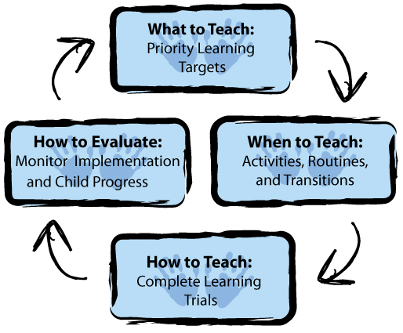
- Identify and align target skills.
- Write high-quality priority learning targets.
- Use high-quality activities to provide multiple, meaningful, motivating (M3) embedded learning opportunities.
- Develop and use activity matrices to guide when, where, with whom, and how many learning opportunities embedded within and across activities.
- Implement embedded learning opportunities as complete learning trials (learning “links”).
- Collect and analyze data about implementation and child progress to inform instructional decisions.
Practice-Based Coaching (PBC)

Practice-Based Coaching | Strengths to Build On | Opportunities to Grow
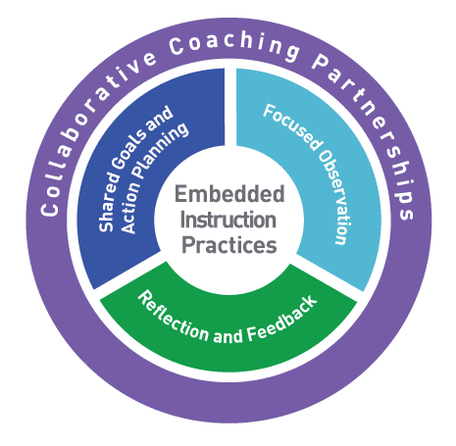
Key Parts:
- Effective Practices (e.g., Embedded Instruction, Pyramid, Early Literacy)
- Shared Goals & Action Planning, including a Strengths and Needs Assessment
- Focused Observation
- Reflection and Feedback
- Collaborative Partnership

Essential Coaching Strategies:
- Observation
- Reflection
- Supportive Feedback
- Constructive Feedback
- Identifying Materials & Resources

