The Hexagon: An Exploration Tool
Adapted from: the National Implementation Research Network (NIRN) http://nirn.fpg.unc.edu

Purpose: This tool is designed to be used by a Core Leadership Team (CLT) with diverse perspectives to facilitate a discussion of the six contextual fit and feasibility indicators for implementing a new practice in a given context. The Hexagon Tool is an important first step in developing buy-in from members of the CLT as well as all EI and ECE staff.
Practice Indicators assess the extent to which a new set of practices that will be implemented demonstrate evidence, supports for implementation, and usability across a range of contexts.
Implementing Site Indicators assess the extent to which a set of practices align with the implementing site along the domains of population need, fit, and capacity. The assessment provides guiding questions to develop a strong match for need, fit, and capacity.

Instructions: The CLT reviews and discusses the questions for each indicator and documents relevant considerations in the Notes section. Any details or thought to prompt later thinking and action planning should also be documented in this section. It is not necessary to write an answer to every question, but the team should clearly identify and consider the broad needs to be addressed for each of the six indicators.
Core Leadership Team: _________________________________ Date: ______________________
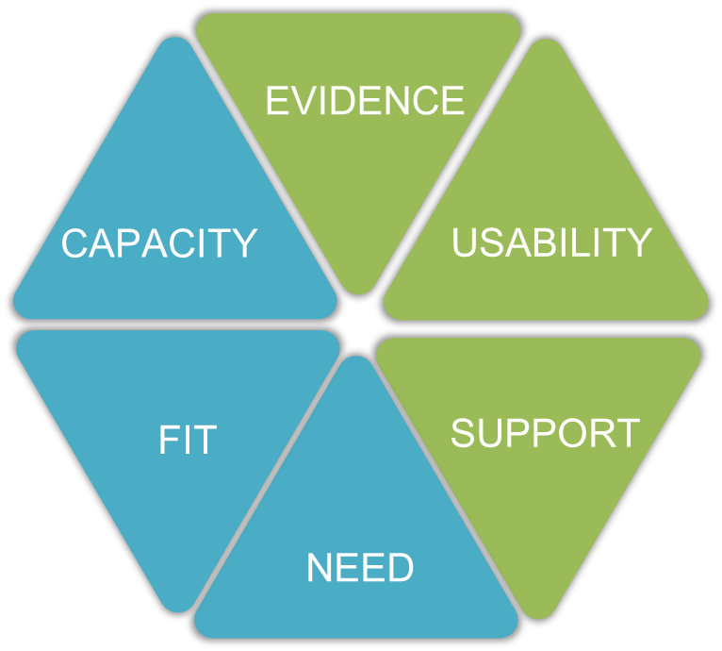

Need
- What do your Preschool EI staff, ECE programs, and related service providers perceive as their needs related to service delivery in inclusive settings?
- What other community partners (e.g., school districts, community organizations) have needs related to understanding EI service delivery?
- If embedded instruction is implemented, what could potentially change for your Preschool EI staff, ECE programs, and community partners?
- What data could you collect to understand the need for embedded instruction better? How could you analyze existing data to identify specific area(s) of need relevant to embedded instruction and/or service delivery?

What information or data would you need to answer the questions?
What barriers could you encounter? What resources could you use?

Notes:

Fit
- What other initiatives are currently used in your program, and will it become easier or more difficult to implement embedded instruction?
- How does embedded instruction fit with diverse family and community values and assets in your area?
- How does embedded instruction fit with how services have historically been delivered, and what is the potential impact?
- How will embedded instruction impact various roles & responsibilities of Preschool EI staff and ECE programs?
What information or data would you need to answer the questions?
What barriers could you encounter? What resources could you use?
Notes:

Capacity
- How does the leader’s knowledge and development of procedures support the work of Preschool EI staff?
- How will you allocate the necessary fiscal and human resources required to support embedded instruction?
- Have Preschool EI staff had prior training in embedded instruction and how does it impact this initiative?
- Do you have a plan for sharing and communicating with all community partners?
What information or data would you need to answer the questions?
What barriers could you encounter? What resources could you use?
Notes:

Evidence
- What information needs to be shared to increase understanding and “buy in” from organizational leaders, Preschool EI staff, ECE programs, and related service providers?
- Thinking about the identified evidence – do you have a plan to share this information with those who need it?
- What additional evidence/information do you need in order to support the roll out of Coaching Across Settings and specifically Embedded Instruction for Early Learning in your program?
What information or data would you need to answer the questions?
What barriers could you encounter?
What resources could you use?
Notes:

Usability
- Is your Core Leadership Team able to explain to others how Early Intervention Service Delivery: Coaching Across Settings is driven by a need for consistency in delivering high quality services?
- What resources or information will you use to share that message?
- Is your team able to support those who have had previous training to understand the need to demonstrate the implementation of skills and practices consistently and with fidelity?
- Can this message be related to how families are supported through consistency across organizations, Preschool EI staff, ECE programs, related service providers, and the state?
- Is your team able to share information regarding the Principle of Early Intervention in Pennsylvania, how they are demonstrated through Embedded Instruction, and how those are applicable to all disciplines?
- What resources or materials will be used to share that information?
What information or data would you need to answer the questions?
What barriers could you encounter? What resources could you use?
Notes:

Support
- What information or support do you need to better understand the roles and carry out the functions of your Core Leadership Team?
- What information do others in your program need to understand the roles and functions of the Core Leadership?
- What other groups are needed to support implement of Early Intervention Service Delivery: Coaching Across Settings in your county (ex. IU or School District administration, ECE directors)?
- What support can these groups offer and how can it be obtained?
- What technology supports does your program already have in place; what might be needed?
What information or data would you need to answer the questions?
What barriers could you encounter? What resources could you use?
Notes:

