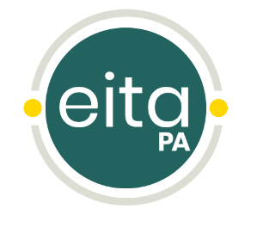

Pre-Registration Act 48 Important Dates

EITA pre-registration courses are on the PaTTAN Training Calendar for three months at a time. Users will
register and complete the online course at any point during that quarter.

How the Quarters are divided:

Registration open: | Course must be completed by: | Certificate in PERMS by:
July 1 - September 21 | September 30 | October 31
October 1 – December 21 | December 31 | January 31
January 1 – March 21 | March 31 | April 30
April 1 – June 21 | June 30 | July 31

